**Ideation Phase**

**Brainstorm & Idea Prioritization Template**

|  |  |
| --- | --- |
| Date | 28 June 2025 |
| Team ID | LTVIP2025TMID40163 |
| Project Name | GrainPalette – A Deep Learning Odyssey in Rice Type Classification Through Transfer Learning |
| Maximum Marks | 4 Marks |

**Brainstorm & Idea Prioritization Template:**

**Step-1: Team Gathering, Collaboration and Select the Problem Statement**



**Step-2: Brainstorm, Idea Listing and Gro**

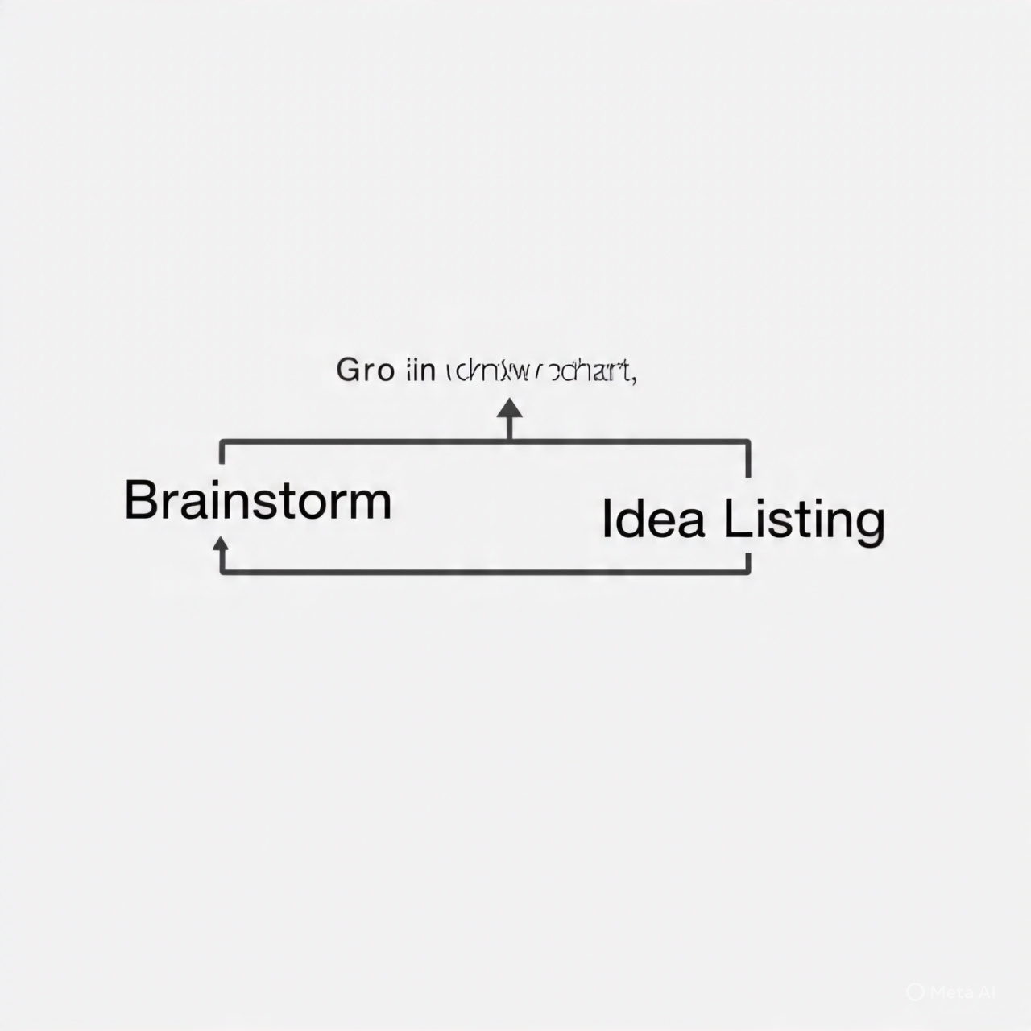

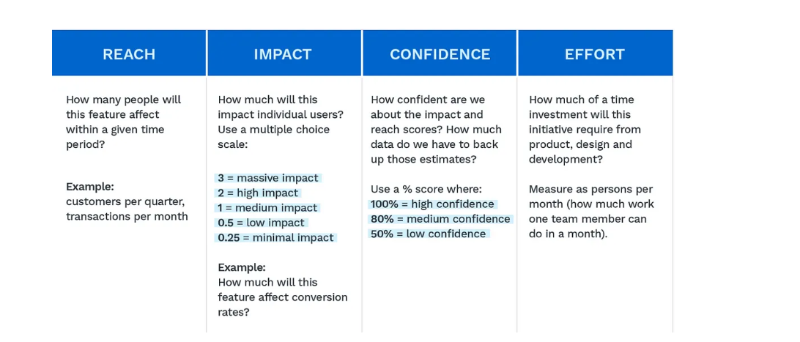

**Step-3: Idea Prioritization**

